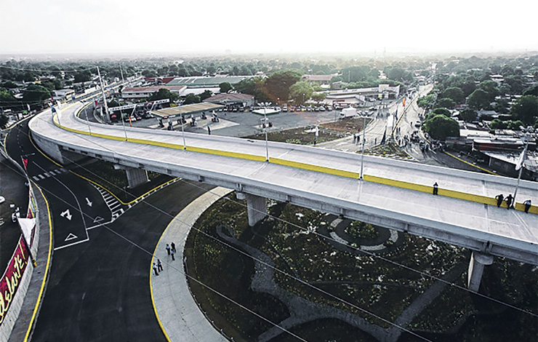
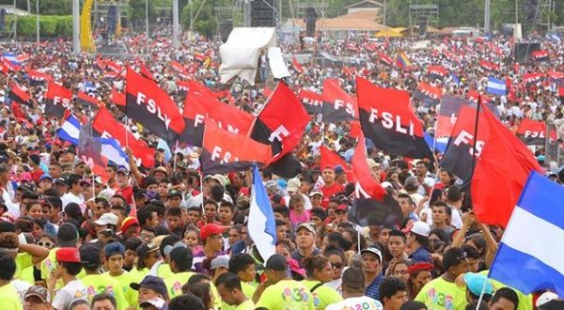
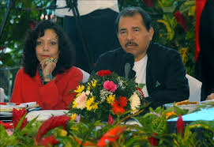
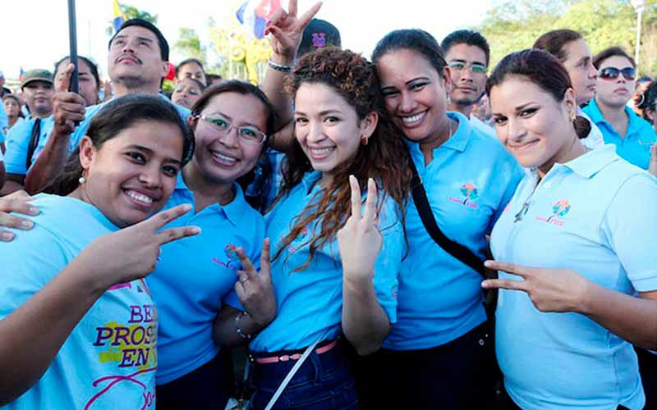

THE STRENGTH OF THE SANDINISTA MODEL

MAY 2020
Content

THE STRENGTH OF THE SANDINISTA MODEL 4
SOCIAL STRENGTH 9
GRUN SOCIAL PROJECTS: 9
LEGAL FRAMEWORK THAT STRENGTHENS THE GRUN'S CHRISTIAN, SOCIALIST AND SOLIDARITY MODEL. 14
INTERNATIONAL RECOGNITION OF THE GRUN'S SOCIAL PROGRAMS. 16
ENVIRONMENTAL STRENGTH 17
ECONOMIC STRENGTH 23
GOOD PERFORMANCE OF MONETARY POLICY 27
GOOD PERFORMANCE OF GOVERNMENT FINANCE 28
A PRO-INVESTMENT GOVERNMENT 28
WORLD ECONOMIC FREEDOM REPORT 29
CONNECTIVITY AND MARKET ACCESS 30
INVESTMENT PROMOTION LAWS 31
COMPETITIVE OPERATING COSTS 32
MINIMUM WAGE 32
TELECOMMUNICATIONS COSTS 35
INTERNET COSTS 36
WATER SERVICE COSTS 36
ENERGY COSTS 37
PRODUCTIVE STRENGTH 38
The Production, Consumption and Trade System 38
The dialogue and consensus model 39
The focus on Family, Community, Cooperative and Associative Economy 39
The new approach in the Creative Economy 40
HOW DOES NICARAGUA ADVANCE DESPITE UNILATERALLY IMPOSED SANCTIONS 41
COVID-19 AND THE GREAT DEPRESSION 2020 42
Tourism 43
Renewable energy 43
Mining 45
Forestry 45
Private forest plantations 46
Sustainable agriculture and livestock 47
Fishery and aquaculture 49

THE STRENGTH OF THE SANDINISTA MODEL
The strength of the Sandinista Model is based on characteristics and results. The characteristics are that the FSLN is patriotic, democratic, it promotes inclusion and participation under the concept that the Peoples are the President and the manifestation of Popular Power. The FSLN (Sandinista National Liberation Front) defends popular interests, enjoys the confidence of the people, and has a social and political base with a high degree of commitment, which constitutes the basis of its great capacity to organize and mobilize the Nicaraguan society through volunteerism.
At the current stage of the Sandinista Revolution, the People as Leaders, facilitated by a Good Government based on the values ​​and principles of the people themselves, have reaped significant social, environmental, economic and productive results, after so many years of sowing in struggle.
It is the characteristics and results previously described that largely constitute the strength of the Sandinista Model. Historically and currently, the groups opposed to the Sandinista Front form a political enclave mastered and guided by North American foreign policy.
The Sandinista Front is the patriotic backstop of the Nicaraguan political spectrum, heir to the struggle of Sandino and Zeledón and the entire history of defending self-determination, independence and sovereignty.
The Sandinista Front is the father of democracy in Nicaragua. Before the 1984 elections, there was nothing quite like a sovereign and free election. In 1990, the FSLN became the first political force to transfer power peacefully with the results of a free and sovereign election.
In the period 1990-2007, the FSLN made a loyal opposition and acted within the constraints of the Constitution, even when there were periods of governance crisis due to the weakness of the governments in power.
Of course, democracy is more than just elections and it is the Sandinista Front that has promoted the inclusion and massive participation of the Nicaraguan People under the concept of the People as President and a the manifestation of Popular Power.
In the entire history of Nicaragua, it is only with the two governments of the Sandinista Front, that the popular interests of the great majority, that are poor, have been prioritized.

One of the strengths of the GRUN Model is the confidence that the people have in the Sandinista Front and in the wisdom of Commander Daniel Ortega to defend and promote the interests of the poor even in difficult circumstances; a trust that has a historical root that comes from the fight against Somocismo, the fight in the 1980´s against the Contra backed by the CIA and two North American administrations, the policy of Governing from below, defending the interests of the poor during the 16 years of neoliberal governments and in the current government in which the leading role of the people, facilitated by the government, has made significant progress for the poor, for women, for indigenous people and people of African descent, that is, a trust forged in historical practice.

Another strength of the model is the high level of commitment toward a solid social and political base, with proven loyalty and a willingness to sacrifice. This forms the basis for the extraordinary capacity to organize and mobilize the Nicaraguan people, through volunteerism, which includes a large percentage of the people themselves, especially youth and women.
The Sandinista Popular Revolution has had clear stages: In the first stage the objective was the national liberation from tyranny. In the second, revolutionary transformations were advanced for the people, but in the end the objective was to survive the brutal American aggression of a decade. In the third stage, the objective was to defend revolutionary advances from neoliberal attempts to reverse them. It is in the current fourth stage that the people, as leaders, facilitated by Good Government based on the values ​​and principles that the Nicaraguan people have reaped, after so many years of sowing in struggle; significant social, environmental, economic and productive results.
The people have recognized the progress with votes in the polls for the Commander: 38% in 2006, 62% in 2011 and 72% in 2016.
The growing strength of the FSLN and its successful model, as well as the weakness of a disjointed opposition, led a part of the opposition and the United States in 2018 to try to add Nicaragua to the list of coups d'état and attempts sponsored by imperialism in this century: Venezuela (2002), Honduras (2009), Ecuador (2010), Paraguay (2012), Brazil (2016), Bolivia (2019).
Armed roadblocks on highways and streets; the armed invasions of neighborhoods and houses; the burning of city halls and other buildings, vehicles and construction equipment; looting of stores and other businesses; the kidnapping, torture and murder of Sandinistas; 198 people died, including 24 policemen, while 401 policemen were wounded by bullets; all this in the midst of a false news campaign and massive psychological warfare based on the media and social networks. In the end, the coup collapsed and the people triumphed, showing the strength of the model.

SOCIAL STRENGTH

GRUN SOCIAL PROJECTS:
The GRUN has promoted a model of human development and participatory, representative democracy and social justice, which can be verified in:

The transformation of health, education and recreation, among others, to which the entire population can access without exclusion and without distinction. Everyone has the right to enjoy the benefits that may be granted to them.

The prioritization of public investment or state investment in areas of Human Development has been guaranteed every year in the GRUN budget that invests in free health and education, as well as to guarantee security, food, care and protection, as well as the right to have decent housing for the people of Nicaragua.
The expansion of the coverage and quality of drinking water and electricity services, as well as highways and roads. New roads have been built, and electricity has been brought to almost the entire country (97.57%) and drinking water to areas of the country that lacked these benefits.
The creation, expansion, and restoration of parks in all the municipalities of the country. New parks have been built and existing ones in need of repair, have been improved.
The massification of sports at the national level, among children, adolescents and youth has not only built new sports spaces, but it has also promoted and facilitated access for all the general population to these places for recreation.
The rescue, protection, safeguard, promotion and dissemination of the historical and cultural heritage, taking care of museums, as well as the implementation of programs so that the population can visit the historical sites of the country and learn about the culture of the peoples in general.
Regarding labor rights, the rights of workers have been defended and the culture of entrepreneurship has been implemented, which has promoted new sources of work and employment.
In the area of ​​Social Security, the affiliation of workers has increased, particularly by expanding in rural areas, cooperatives, unions, home help and self-employed workers.
On land ownership and planning, property titles have been delivered to people who live in different areas without possessing legal documents.
In relation to prevention and care in the family, we have been promoting not only laws, but education at all levels for the care and protection of families in general.
For people with different disabilities, we have been guaranteeing a culture of respect, ensuring that these people can have the right and access to jobs, education, regardless of their condition.
As for the elderly, laws have been promoted that benefit older adults, creating comprehensive care centers, discounts on payments for their basic services (electricity and water), as well as favorable prices for access to touristic sites.
Likewise, the GRUN has developed:
Maternal Homes in Nicaragua. Pregnant mothers are accommodated by providing pre-delivery care and the newborn is cared for.
Love for the little ones. Its objective is the early stimulation of boys and girls under the age of six, a process that begins from the prenatal period and promotes breastfeeding, surveillance, growth and development, as well as the vaccination process, ensuring health, nutrition and personal hygiene of minors.
Snack and School Packages: It consists of the preparation of food in the study centers by the parents with meals provided by the government, along with school supplies delivered to the boys and girls.
Literacy and Youth and Adult Education: It allows people who do not have studies, to complete them in a short time.
Zero Usury Program: It is a program aimed at women who are self-employed, providing them with improved credit terms and interests rates that are less than the ones offered by banks and “small loan institutions”.
All with A Voice Program: Personalized attention to people with disabilities through medical check-ups, delivery of medications, food packages, education, among other benefits.
Solidarity Roof Plan: Consists of the delivery of sheets of zinc for families in need to improve their living conditions.
Houses for the People: Construction and delivery of social housing for the population living in poverty.
Productive and Food Programs: Delivery of cows, poultry and fruit seeds, to reduce malnutrition and poverty in the short term.

LEGAL FRAMEWORK THAT STRENGTHENS THE GRUN'S CHRISTIAN, SOCIALIST AND SOLIDARITY MODEL.
The GRUN, since 2007 to date has promoted new laws and updated and modernized others, which have as a priority the strengthening and restitution of the rights of the Nicaraguan people. Among these we have:
Laws that guarantee Nicaraguan citizens a better quality of life: Law No. 693, the Food and Nutrition Sovereignty and Security Law; Law No. 721, Law on the social sale of medicines; and Law No. 842, Law for the protection of the rights of consumers and users.
Laws that protect and strengthen the family and its members: Law No. 870, Family Code; Law No. 677, Special Law for the promotion of housing construction and access to affordable housing; Law No. 688, Law for the promotion of the dairy sector and the glass of school milk; Law No. 718, Special Law for the Protection of Multiple Birth Families; and Law No. 720, Law for the Elderly.
Laws that protect the rights of people with some type of special needs: Law No. 675, Nicaraguan Sign Language Law; Law No. 650, Law for the Protection of the human rights of people with mental illnesses; and Law No. 763, Law on the Rights of Persons with Disabilities.
Laws that promote equality, dignity and equity of rights to all Nicaraguans: Law No. 648, Law on Equal Rights and Opportunities; and Law No. 757, Law of dignified and equitable treatment of indigenous peoples and people of African descent.
Laws that promote a life free of violence: Law No. 779, Comprehensive Law against Violence against Women and reforms to Law No. 641 Penal Code.

INTERNATIONAL RECOGNITION OF THE GRUN'S SOCIAL PROGRAMS.
International organizations such as the Inter-American Development Bank (IDB), World Bank, International Monetary Fund, and the World Food Program (WFP), have highlighted and recognized that the Nicaraguan government has made significant progress on issues of poverty reduction in general, the creation of economic opportunities in rural areas for families to produce their food, and the positive performance of the economy, maintaining growth levels that are higher than the average for Latin America and the Caribbean.

ENVIRONMENTAL STRENGTH
Since the Government of Reconciliation and National Unity assumed the destiny of the country, a policy of protection and defense of Our Mother Earth has been put into practice, which is manifested in the proposals of the National Program for Human Development.
The lines of action that are applied to carry out this policy are mainly environmental education; defense and protection of natural resources and forest development; the conservation, recovery, collection and harvesting of water; mitigation, adaptation and risk management in the face of climate change; sustainable land management; the regulation and control of environmental pollution for the conservation of ecosystems and human health; as well as preventing the environmental impact of economic activities that take place in the country.
Within the framework of this policy, year after year, a Great National Reforestation Crusade is promoted as part of a reforestation strategy in forest areas and in regions suffering from land degradation. In this sense, a community forestry model is applied, in which the indigenous and Afro-descendant communities of the Caribbean Coast of Nicaragua are actively involved, as well as farmers along the agricultural frontier. On the other hand, Nicaragua received the approval of the Forest Carbon Cooperative Fund, through which rural communities and indigenous peoples living in the forests of the Caribbean Coast, Bosawás and Indio Maíz, will reduce deforestation and forest degradation, reducing emissions of approximately 11 million tons of Carbon Dioxide and receiving in return positive incentives for 55 million dollars in five years. This goal only represents 50% of the potential of the Caribbean region in reducing emissions. This is done through the MARENA ENDE-REDD + program, with the assistance of the World Bank.
The technological and technical capacities of MARENA, INETER, INAFOR and Regional Governments of the Caribbean Coast have been strengthened, with the establishment and operation of a forest monitoring system, which will allow the monitoring, recording and verification of the reduction of carbon emissions and the greenhouse gas effect due to deforestation and forest degradation processes at the national level and direct actions for the restoration of forest landscapes.
In the search for the use of water resources, the construction of water harvesting works and reservoirs for productive uses and recovery of this vital liquid is promoted. All of this within a strategy that seeks to recover and preserve water, the potential of water in river basins, soil fertility and the conservation of the flora and fauna of our country, which constitutes between 7% and 8% of the world's biodiversity.
At the international level, the GRUN has stood out in firm defense of Mother Earth and has raised its voice so that the whole of humanity mobilizes to reverse the consequences of climate change. Nicaragua has been a banner for developing countries in discussions in the different spaces of the United Nations Convention on Climate Change, maintaining the principles of "common but differentiated responsibilities", "historical responsibilities of developed countries", "the principle of cooperation” and “the principle of respect for sovereignty” Nicaragua also stresses the need for developed countries to assume a moral commitment to finance developing countries in their efforts to mitigate, adapt, and address loses and damages caused by centuries of pollution from developed countries. Nicaragua has an active participation in the different decision-making instances of the Climate Change Convention such as the Green Climate Fund, the Permanent Finance Committee, the Subsidiary Bodies, among others.
Nicaragua signed the Paris Agreement in 2017, because in most countries of the world there was a consensus that the 2015 commitments in Paris are insufficient to prevent an increase in the global average temperature to 2ºC and much less to 1.5ºC, and also agree that the reduction goals for gases such as CO2 and methane in developed countries should be increased. Thus, Nicaragua's solitary position in Paris in 2015, became a consensus position in 2017.
The State of Nicaragua has continued to collaborate with the international community in promoting collective action on climate change, maintaining a firm and coherent position in defense of the environment and making continued efforts to adapt and mitigate the consequences of climate deterioration.

Our government has met the goals, commitments and agreements of the Climate Change Convention and the goals for reducing emissions have been defined through the reports of the "National Determined Contributions", which are currently in the process of being reviewed and improved to define our goals in terms of reducing gas emissions.
A national policy for mitigation and adaptation to climate change has been defined. This policy has a focus on sustainable development, compatible with disaster risk management, innovation and efficient use of resources, an ecosystem approach, gender equity, citizen participation, feasibility of measures, climate finance, recognition of indigenous peoples and indigenous communities, and education on climate change.

ECONOMIC STRENGTH
The IMF projects that the world economy will suffer a sharp contraction of -3% in 2020, much worse than that registered during the financial crisis of 2008–09. ECLAC, for its part, forecasts -5.3% for the Latin American region in 2020. On the other hand, according to the estimates of the OECD (Organization for Economic Cooperation and Development), measures like the ones currently in place could reduce the world economy by -2.0% per month, or an annualized rate of -24%, approaching the levels of the Great Depression of the 930s.
The COVID-19 pandemic is inflicting a huge and escalating human cost worldwide. The health crisis is also having a serious impact on economic activity. Preliminary data for the response to the pandemic for the first quarter of 2020 indicate that the US economy (Gross Domestic Product, GDP) fell -4.8%, the largest decline in the first three months of the year since 2008 during the global financial crisis, when the US economy contracted by -8.4%
According to the Central American Integration System (SICA), through the Central American Economic Integration Secretariat (SIECA) and together with the Executive Secretariat of the Central American Monetary Council (SECMCA), the updated scenario with the perspectives collected as of April 2020, estimates for 2020 a decrease in the economy of Central America of -6.9% and a rate of generalized and sustained increase in the prices of goods and services (inflation) of 0.6% for the region. By 2021, the decrease in the economy at the regional level would be -1.4% and the estimated inflation rate would be 1.9%.
Some estimates also indicate that 29 million people in Latin America could fall into poverty, reversing a decade of efforts to reduce income inequality.
Faced with such unfavorable scenarios at the regional level and the world in general, the Government of Reconciliation and National Unity (GRUN), has not closed the economy, nor declared an absolute quarantine, since in Nicaragua approximately 80% of employment is informal, working brothers and sisters who live from day to day, and while 41% of the population lives in the countryside and require activities outside the home every day. All of them would be seriously affected. Added to this, that since the crisis of April 2018, GDP has experienced a successive contraction of up to -4.0% in 2018 and -3.9% in 2019.
The government, in addition to attending and facing the pandemic, is having to defend itself from the media attack and appeals to "stay at home", promoted by the leaders of the failed coup, with the aim of further destroying the economy, hindering productive and commercial activities, which would cause significant losses in household income and in the economic performance of companies, especially small and medium-sized ones. Government policy is protecting peasants, informal workers, small and medium-sized enterprises, the poor in general, and the national economy.
The strategy of balance of the GRUN and its Christian, Socialist and Solidarity Model, from the first day, has been to keep the economy afloat, reduce poverty and inequality levels, promote a monetary and financial policy of the government in harmony and in times of crises, like the one we are currently going through, avoiding a catastrophe in GDP by the end of 2020.
We have in our favor the flow of agricultural activities, productive transformation and provision of public services for families in the countryside and cities; the supply of basic consumer products has been maintained, while the price level of the products and services that the population demands daily remains stable. This contrasts with other countries where there has been panic buying and speculative price rises leading to shortages.

GOOD PERFORMANCE OF MONETARY POLICY
The policies implemented by the BCN and the good performance of the variables of the monetary sector led to the strengthening of the Gross International Reserves (RIB). Thus, the RIB closed 2019 at a higher level than in 2018 (2,397.4 million dollars). The exchange rate remained as expected, inflation was stable in one digit and the total amount of cash in the hands of the public (Monetary Base) stands at C$34,477.7 million, C$4,345 million more than in 2018.

GOOD PERFORMANCE OF GOVERNMENT FINANCE
Government finances showed good performance in 2019, the execution of the State budget and its components (public spending and taxes) were handled in a prudent manner. As a result of this, public debt has shown a tendency to decrease.
Likewise, the Christian, Socialist and Solidarity Model has been in charge of providing generous incentives to attract more investment to the country, especially for export-oriented sectors, including free zones, tourism, mining and forestry.

A PRO-INVESTMENT GOVERNMENT
The Government of Nicaragua recognizes the positive impact of foreign direct investment (FDI) in an economy like that of Nicaragua, so it actively and openly promotes it as a country committed to its employees, the community, and the environment.
The appointment of a Presidential Delegate for Investments to coordinate investment promotion efforts and ensure the successful development of these projects reaffirms the government's positive stance towards foreign direct investment.
PRONicaragua, the official investment promotion agency, was highlighted with the best results among all investment promotion agencies in the world in the 2012 Global Comparative Study of Investment Promotion (GIPB), published by the World Bank, International Finance Corporation (IFC) and the Multilateral Investment Guarantee Agency (MIGA).

WORLD ECONOMIC FREEDOM REPORT
Nicaragua's economy is among the freest in the world, according to the recent World Economic Freedom (EFW) report, published by the Fraser Institute. In the 2018 edition of the report, the country ranked 54 out of 162, with a score of 7.27 out of 10.
This annual report measures economic freedom (levels of personal decision, ability to enter markets, security of private properties, the rule of law, etc.) by analyzing the policies and institutions of more than 160 countries and Hong Kong.

CONNECTIVITY AND MARKET ACCESS
Nicaragua's geographical position and its connectivity with the rest of the world, in addition to the benefits related to the different preferential access agreements, increase its potential to export to non-traditional markets.
Preferential agreements have become an important component of trade liberalization in Nicaragua, therefore, the country continues to seek opportunities to ensure its successful insertion in international trade and the global economy.
Likewise, Nicaragua has signed Free Trade Agreements with the United States, Mexico, Panama, Taiwan, the Dominican Republic, Chile, South Korea, Ecuador and the European Union. It also belongs to the Central American Common Market, to the Bolivarian Alliance for Peoples Of Our America (ALBA) and a Generalized System of Preferences with Japan, Norway, Canada, Russia and Switzerland and has additional treaties under negotiation.

INVESTMENT PROMOTION LAWS
The relevant laws regarding Investment Promotion are: Law Nº. 344, Law for the Promotion of Foreign Investments; Law No. 822, Tax Agreement Law; Law No. 382, Law of Temporary Admission Regime for Active Improvement and Facilitation of Exports; Law No. 917, Free Export Zones Law; Law No. 532, Law for the Promotion of Electric Generation with Renewable Sources; Law No. 387, Special Law on Exploration and Exploitation of Mines; Law No. 306, Incentives Law for the Nicaraguan tourism industry; Law No. 694, Income Promotion Law for Retired and Retired Residents.

COMPETITIVE OPERATING COSTS
Nicaragua offers one of the most competitive cost structures in the region, which allows companies to increase their competitiveness and reduce their operating costs and provide greater added value to their products or services.
Before establishing operations in a country, every company must go through an important process of due diligence and evaluation, where operating costs play an influential role in the final result of the decision to invest.

MINIMUM WAGE
Minimum wage in the different economic sectors in Nicaragua range from US$0.92 to US$2.06 an hour, including social benefits.
Social benefits represent an additional 52.0 percent to the minimum wage, these include: social security, contributions to the National Technological Institute (INATEC), paid vacations and Christmas bonuses, among others.

Below are the minimum wages by law for 2019:
Minimum Wage 2019 (Dollars
Sector | Monthly US$ | Hourly US$
Construction, Financial Services and Insurance | 428.79 | 2.06
Electricity and Water, Commerce, Restaurants and Hotels, Transportation, Storage and Communications | 351.44 | 1.68
Mines and Quarries | 344.11 | 1.65
Fisheries | 291.34 | 1.4
Personal and Communal Community Services | 268.61 | 1.29
Manufacturing | 257.63 | 1.24
Fiscal Regime Industries | 271.19 | 1.3
Central and Municipal Government | 238.94 | 1.15
Small and Micro Artisanal Industries and National Tourism | 205.87 | 0.99
Agribusiness* | 191.6 | 0.92
Fuente: Ministerio del Trabajo (MITRAB). Tasa de cambio promedio 2019: 33.13. Incluye beneficios sociales. *Salario mínimo más alimentación.

Regarding companies that are under the free zone regime, the minimum wage is the most competitive at the regional level, which makes Nicaragua an ideal country to establish labor-intensive operations, as can be seen in the following table:

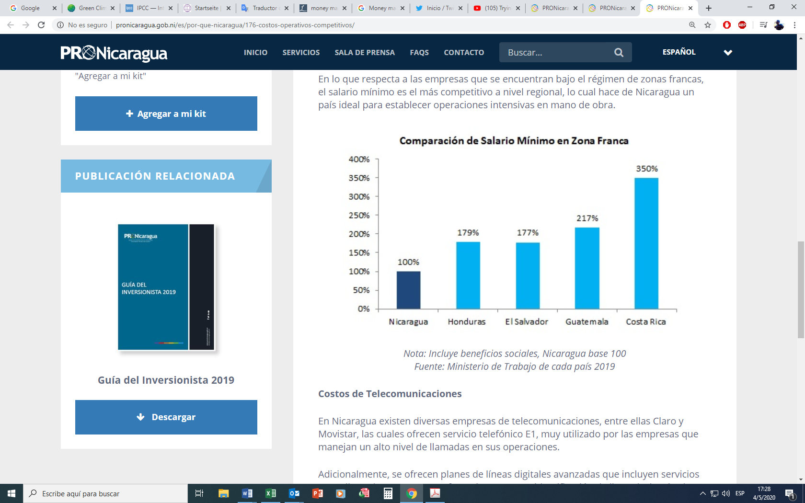
Nota: Incluye beneficios sociales, Nicaragua base 100
Fuente: Ministerio de Trabajo de cada país 2019

TELECOMMUNICATIONS COSTS
In Nicaragua there are several telecommunications companies, including Claro and Tigo, which offer E1 telephone service, widely used by companies that handle a high level of calls in their operations. Additionally, advanced digital line plans are offered that include services such as call waiting, three-way conference, caller ID, voicemail, and text messages (SMS). In these types of plans, the cost per minute for international calls to the United States and Canada is approximately USD $ 0.20 / min.

INTERNET COSTS
The main providers of business connections in Nicaragua are Claro, Amnet, Navega, IBW, Ideay, among others. All of them offer various dedicated business data packages whose approximate average prices can range from $70 for a 256 K/s connection to $640 for a 3,072 K/s connection.

WATER SERVICE COSTS
The Nicaraguan Company of Aqueducts and Sanitary Sewers (ENACAL) is the entity in charge of providing the country's water and sewerage service. This company is regulated and controlled by the Nicaraguan Institute of Aqueducts and Sewers (INAA). In Nicaragua, an average company whose monthly consumption is greater than 50 m3 of water has an approximate rate of US$0.40 per m3. ENACAL also applies a charge per m3 of consumption to companies with private wells.

ENERGY COSTS
In Nicaragua, the energy distribution service is provided by the company DISNORTE-DISSUR and is regulated by the Nicaraguan Energy Institute (INE). Industrial companies have the option of opting for energy rates with or without time discrimination. For an industrial company with a monthly contracted load greater than 200 KW and under this category without discrimination, the cost per KWh consumed is around US$0.19.
Additionally, for companies with a minimum concentrated load requirement of one megawatt per month, there is the option of opting for the "Large Consumer" category and obtaining a preferential rate by purchasing directly from the generators.
In the same way, self-generation of renewable energy for self-consumption is allowed and even better, according to law 1011 to reform article 32 of Law 272 Law of the Electric Industry, the sale of surplus Electric Power delivered by the Generator to the distribution network and that is committed by means of an energy purchase and sale contract with the Distributing Companies, will be exempt from the application and / or withholding of all kinds of taxes, fees and special contributions, given that the Generator is not an Economic Agent.

PRODUCTIVE STRENGTH

The Production, Consumption and Trade System
The coordination between the policies, programs, projects and specific actions developed by the different levels of government, allows for greater effectiveness in the implementation of sectoral and national plans, as well as greater efficiency and transparency in the execution of the national budget and funds from external sources, all this based on the National Program for Human Development, the integrated work of State institutions and framed in the Model of Dialogue and Consensus of the Government of Reconciliation and National Unity (GRUN).

The dialogue and consensus model
Under this model sectoral policies, as well as the programs and projects directed to the development of the productive sectors, are formulated and executed with the effective prominence of the local actors.
This allows for private actors to feeling not as "beneficiaries" of public policies, but as "protagonists", actively participating in the processes, and also that these policies, programs or projects correspond effectively to the productive, environmental, economic and social realities of the territories in which they will be executed.

The focus on Family, Community, Cooperative and Associative Economy
Since its inception, the GRUN identified that more than 70% of employment and 40% of Nicaragua's GDP were generated by the family, community and cooperative economy and that the actions that were being developed through the famous “Zero Hunger” programs and “Zero usury” in order to reduce the vulnerability of rural and urban families submerged in poverty by neoliberal governments, would have the potential to significantly increase these percentages of contribution to employment and national production, and would be a fundamental part of the successive National Human Development Plans and Programs. Since 2012, when the Ministry of Family, Community, Cooperative and Associative Economy (known as MEFCCA) was organized, this sector has been strengthened.

The new approach in the Creative Economy
Among the axes of the National Program for Human Development 2018-2021 is the implementation of an entrepreneurial culture, developing programs at all levels that stimulate teaching-learning, innovation, improved management, productivity and competitiveness of Undertakings in strategic alliances with and between private institutions, the central government, municipalities and social organizations.
The Creative Economy, from the strategic vision of the government and its institutions, allows for the achieving of higher levels of productivity, added value, professional qualification, quality work, competitiveness of SMEs and all companies, and the development of the country, by promoting the consolidation of national and local institutions, the development of infrastructures, the promotion of markets and businesses, the strengthening and stimulation of human talents, the production and use of knowledge and technologies, and the increase in creative production.

HOW DOES NICARAGUA ADVANCE DESPITE UNILATERALLY IMPOSED SANCTIONS
Despite the economic aggressions promoted and imposed by the United States Government, such as the "Nica Act", Nicaragua is working together with missions abroad, with solidarity countries willing to contribute to the progress and economic development of the country in executing an active resource and investment management policy with the international community.
Regarding investment, despite coercive measures, we continue to be an important platform for investment and export to the international market; therefore, investment in Nicaragua has continued to develop. Nicaragua has friendship and cooperation agreements with friendly countries and foreign companies have bought national manufacturers; investment in sectors such as agribusiness, infrastructure, tourism, energy and Mining is being promoted; Entrepreneurs and companies continue to arrive eager to invest in opportunities in Nicaragua.

COVID-19 AND THE GREAT DEPRESSION 2020
Given the Great Depression (economic crisis), there will be few countries in the developing world that are stable and with open economies, that is, without capital or profit flow controls. Thus, they will be able to attract foreign investment with solid opportunities. That is the case of Nicaragua in terms of tourism, renewable energy, mining and forestry.

Tourism
In Nicaragua, as in the whole world, one of the economic sectors that has been hit the hardest by the COVID-19 pandemic has been tourism, a sector that was already suffering the consequences of the failed coup of the year 2018. Upon exiting the Pandemic, all tourist countries will start from the same position of zero.
The recovery potential of the Nicaraguan tourism sector is great since several specialized media have been publishing, even in times of pandemic, articles highlighting important aspects of Nicaragua, such as the beauty of its colonial cities, extreme sports on the slopes of its volcanoes and the variety of its landscapes and ecosystems, as well as its high citizen security and low costs, which are some of its distinctive features. At the same time, the GRUN has been making significant investments in infrastructure that improve access and facilities in places of great tourist potential.

Renewable energy
Nicaragua is the country of lakes and volcanoes to which it is added that geographically it is located in the tropical region of the planet, affording our country a huge potential for the production of renewable energy from our natural resources, allowing the generation of photovoltaic, wind, geothermal and biomass energy. The National Electric Transmission Company (ENATREL) is executing new electric power projects in Nicaragua; at this time, they are working on the construction and expansion of 18 energy substations, this investment consists of 300 million dollars.
This range of natural conditions that the country has to produce environmentally friendly electricity and foreign investment facilities has sparked the interest of investors to produce enough energy to export and sell it through the SIEPAC Network that connects all of Central America, from Guatemala to Panama.

Mining
Metal mining has been a traditional economic activity in Nicaragua, due to the recognized wealth of its gold and silver mines, but lately its potential in multimetal mines has also been recognized.
The installation of a metal refinery in the country would allow us to add national added value to mining exports, and even open the possibility of capturing ore from other countries in the area and processing it in Nicaragua.

Forestry
It has been estimated that around 44% of the national territory (5.3 million hectares) is land with a pure forest vocation, while an additional 29% (3.5 million hectares) is land suitable for production under agroforestry or silvopastoral systems.
The Government of Reconciliation and National Unity has established a reforestation strategy, based on public efforts with different specific programs to recover protected areas, through forest plantations in degraded areas and on soils with a forest vocation.

Private forest plantations
In recent years, the private sector in Nicaragua has invested about $150 million dollars in the forestry sector, and several private companies continue to expand their investments in conditions that favor our country, given the situation of many precious wood species that were exploited in Southeast Asia, which is suffering from indiscriminate exploitation, since it is the lucrative business of the military leaders that govern various countries in that part of the world.
Currently the sector has a management area of ​​32,899 ha including its planted and conservation areas.

Sustainable agriculture and livestock
The COVID-19 pandemic has revealed the instability of industrial agricultural production. In contrast, agricultural activity in Nicaragua is fundamentally based on family production. According to data from the 2011 National Census of Agriculture (CENAGRO), 98% of producers and 90% of agricultural land can be characterized within family farming and contributes an estimated 60% of national agricultural GDP, mainly from the production of basic grains (corn, rice, beans and sorghum) and livestock.
This is a strength inasmuch as, on the one hand, family systems do not require further hiring of labor outside the family unit, and, on the other, the marketing of their surpluses is easily carried out in local markets, and it does not depend on complex logistics.
On the other hand, it is possible to foresee that, once the COVID-19 pandemic has been overcome, consumer concern for food safety will increase significantly, and Nicaraguan agricultural production, except for some specific items that are produced in larger industrialized processes (for example, flood rice or sugar cane), are characterized by limited use of agro-toxic inputs.
What will be necessary would be to promote more decisively the sustainable intensification of livestock production, which would allow the producer to increase the animal load, freeing up grazing areas that could be used for reforestation and / or for the diversification of the farm from of agroforestry production.

Fishery and aquaculture
This productive potential is insufficiently exploited, mainly due to the lack of a national flag industrial fishing fleet, so the development potential of the industry is still very great. Due to its coastal lagoons on the Caribbean Coast, Nicaragua also has potential for aquaculture production.
Nicaragua has more than 10 thousand km2 of inland waters, including the 8,264 km2 of Lake Cocibolca and 1,025 km2 of Xolotlán, as well as some 90 coastal lagoons on the Caribbean coast, so its potential for aquaculture production is also great. There is already a shrimp aquaculture industry in Puerto Morazán, on the Gulf of Fonseca, which produced US$40.7 million in exports in 2018.

